Girls on the Run International – Individual Objectives & Assessment

Girls on the Run is committed to individual goal setting to recognize and fully reward performance and contributions of individual employees in achieving the organization’s annual organizational objectives. Individual job objectives based on each employee’s job description are created annually by each employee and her or his manager to fuel performance. These job objectives are ‘SMART’ and clearly align with the employee’s impact on the achievement of department and overall organizational annual goals:
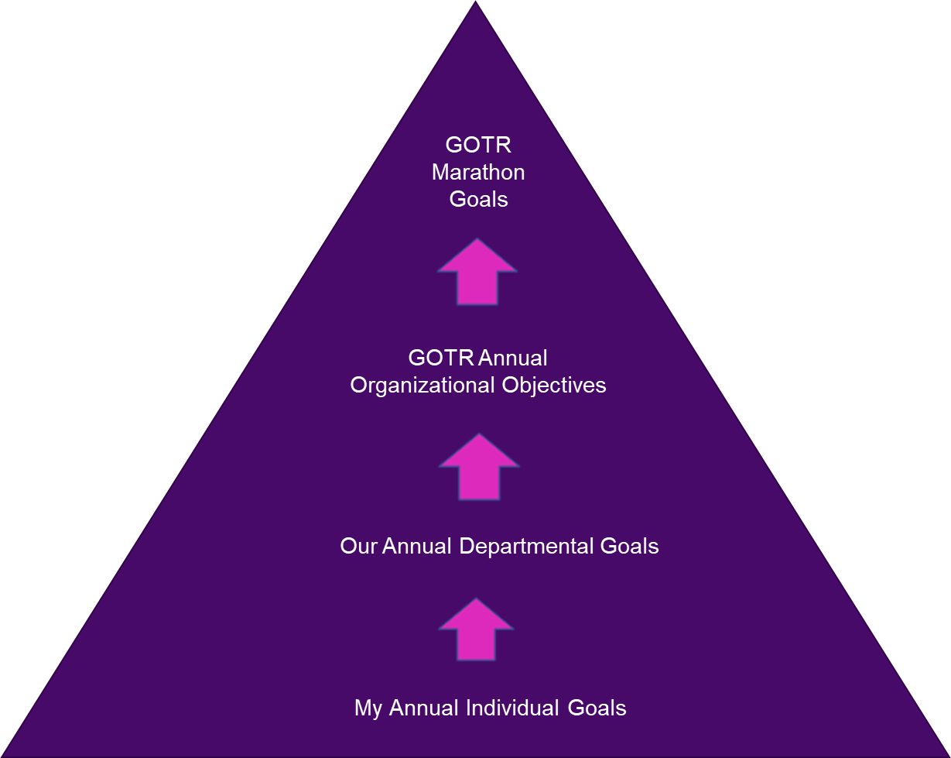
Performance is reviewed based on what employees are achieving and how they are achieving it, including:

- Attainment of individual job objectives – 50%
- Employee’s behavioral alignment with Girls on the Run core values and culture – 50%

Together, these two factors are evaluated on an individual basis in conjunction with the organization’s achievement of the overall organizational objectives.

What are Job Objectives?

- Job objectives communicate major individual responsibilities and the related outcomes that are expected of the employee.
- Job objectives are linked to the annual organizational objectives.
- Job objectives capture large projects, initiatives or expectations – not small daily tasks.

What are ‘SMART’ Objectives?

S: Specific means the objective is an observable action, behavior, or achievement.

M: Measurable means that a method or procedure must exist to objectively assess the quality of the outcomes.

A: Aligned means job objectives throughout the organization are meaningful and working toward the same goal.

R: Realistic: means the achievement of the job objective is something an employee can do to support an organizational goal. The job objective should be achievable with the resources and time available.

T: Timed means there is a point in time when the objective will be completed.

Criteria for Creating Effective Job Objectives

- Are the job objectives results-focused? Can achieving or exceeding them be measured?
- Do the job objectives focus on key initiatives or projects I am responsible for accomplishing during the year?
- Can a “line of sight” be drawn between my job objectives and the organizational objectives?
- Are the job objectives written in a ‘SMART’ framework so that my manager and I have a shared understanding of what is expected?

Girls on the Run International FY2020 Organizational Objectives

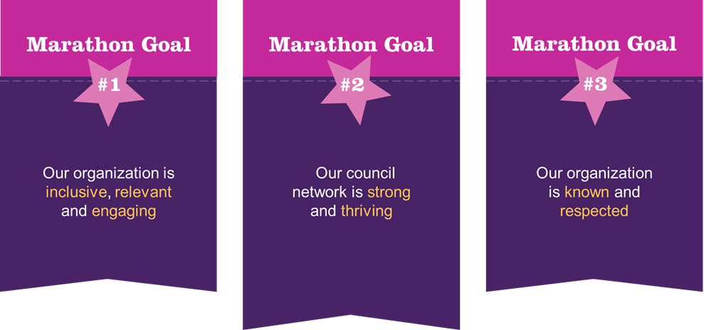
Organizational objectives are designed to meet the marathon goals of Girls on the Run.

Insert organizational goals chart/overview

Overview of Performance Management Process

Girls on the Run employees are evaluated based on achievement of key individual objectives, and the achievement of organizational goals. Employees are also evaluated based on their alignment with Girls on the Run International’s core values and associated behaviors. Expectations for setting and reviewing performance are as follows:

- Employees work collaboratively with their managers to establish their priorities and objectives for the upcoming fiscal year.
- Employees document objectives in the Goals Worksheet, in accordance with ‘SMART’ goal setting (see SMART Goals Workbook).
- In preparation for the mid-year review, employees provide their manager with a written status update.
- Together, managers and employees discuss progress on each objective at the mid-year review and manager submits updated form to HR.
- In preparation for the year-end review, employees provide final status and outcome on each objective to managers.
- Together, managers and employees discuss outcome of each objective, along with overall performance at the year-end review and manager submits completed form to HR.

Several optional forms are available to support the performance management process and may be requested or required by your manager as needed. They can be completed at any time throughout the year.

Self-Assessment form
Provides an opportunity to highlight individual and team accomplishments outside of top objectives, share challenges and opportunities and generate discussions between managers and team members.

Peer Assessment form
Provides valuable feedback from team members, project team members or other individuals within the organization.

Employee Feedback form
Gives employees a guide for providing feedback on their manager’s communication, leadership and behavioral alignment to facilitate dialogue during the year.

Individual Objectives: July 2019 – June 2020

Current Date: | Manager Name:
Employee Name: | Employee Title:

Objective 1
Individual Job Objective
Timeline
Milestones & Key Deliverables | 1.  2.  3.
Organizational objective this supports
Mid-Year Review
Mid-year Check-in Status
(on target, reprioritized, cancelled)
Comments
Manager’s Comments
Year-End Review
Year-End Status
(Achieved, Reprioritized, Unmet)
Comments
Manager’s Comments

Objective 2
Individual Job Objective
Timeline
Milestones & Key Deliverables | 1.  2.  3.
Organizational objective this supports
Mid-Year Review
Mid-year Check-in Status
(on target, reprioritized, cancelled)
Comments
Manager’s Comments
Year-End Review
Year-End Status
(Achieved, Reprioritized, Unmet)
Comments
Manager’s Comments

Objective 3
Individual Job Objective
Timeline
Milestones & Key Deliverables | 1.  2.  3.
Organizational objective this supports
Mid-Year Review
Mid-year Check-in Status
(on target, reprioritized, cancelled)
Comments
Manager’s Comments
Year-End Review
Year-End Status
(Achieved, Reprioritized, Unmet)
Comments
Manager’s Comments

Copy and paste worksheet for additional goals, as needed
Personal Development Goal(s)

Personal Development Objective
Milestones & Deliverables
Mid-Year Review
Mid-year Check-in Status
(on target, reprioritized, cancelled)
Comments
Manager’s Comments
Year-End Review
Year-End Status
(Achieved, Reprioritized, Unmet)
Comments
Manager’s Comments

Personal Development Objective
Milestones & Deliverables
Mid-Year Review
Mid-year Check-in Status
(on target, reprioritized, cancelled)
Comments
Manager’s Comments
Year-End Review
Year-End Status
(Achieved, Reprioritized, Unmet)
Comments
Manager’s Comments
Alignment with Core Values

50% of an employee’s review is based on behavioral alignment with the organization’s core values. Comments are completed at both the mid-year and year-end review and can include examples of these behaviors in action.

Core Value | Behaviors | Comments | Manager Comments
Recognize our power and responsibility to be intentional in our decision making | I consider the GOTR mission and core values in my decisions and actions  I am motivated to accomplish goals and attentive to producing high quality work  I learn from my mistakes and unsuccessful efforts, using the knowledge gained in these experiences to ensure better future outcomes  I am willing to do what is right versus what is easy and will face adversity and make difficult decisions using the GOTR values as my guide  I make decisions in a timely manner, neither procrastinating nor jumping to conclusions
Embrace our differences and find strength in our connectedness | I use collaboration as a tool to develop plans and accomplish goals  I build constructive relationships – up, down and sideways, using diplomacy, kindness and tact  I use GOTR values when navigating conflict and lean in to find common ground in order to resolve disputes  I provide the information people need to know to be productive in a timely manner  I ask questions and listen to better understand viewpoints that are different from my own  I respect others’ time by adhering to established deadlines, only involving people who need to be included and being punctual
Express joy, optimism and gratitude through our words, thoughts and actions | I convey a positive attitude at work, enjoy working hard and am energized by challenging work  I express my gratitude to people – up, down and sideways -when they do good work, embody our core values, or positively impact the organization.  I am cool under pressure and able to maintain my composure; choosing not to react in a defensive or irritated manner to unexpected or stressful situations  I only say things about others that I would say to their face  I celebrate my peers’ accomplishments  I am grateful to work for a mission-driven organization
Lead with an open heart and assume positive intent | I put myself in others’ shoes as a means of better understanding their behavior and decisions  I think before I speak in order to consider how my words and actions affect the entire organization  I practice being vulnerable  I effectively cope with change and can shift gears when necessary  I seek what is best for GOTR in the long run versus what may be better for me or my department in the short run  I respect boundaries and the privacy of others

Nurture our physical, spiritual and emotional health | I thrive in a fast-paced environment and communicate with others when I have a lot on my plate  I maintain a conscious balance and can attend to both my work and personal needs; I am able to effectively adjust when demands in one or the other require  I find joy in work and pursue it with energy, drive and a desire to have an impact  I know my strengths, weaknesses, opportunities and limits and actively work to continuously improve and deploy my strengths  I use my time effectively and efficiently, and can attend to a broad range of activities by concentrating my efforts on the most important priorities
Stand up for ourselves and others | I practice empathy to feel the joy and pain of others  I am willing to push myself out of my comfort zone  I take responsibility to communicate effectively by listening to or reviewing information, asking questions to gain clarity and sharing what I need to be successful  I speak up when I believe others’ actions are inconsistent with GOTR core values

Overall Assessment

When reviewing overall FY2020 performance, use the following guide to assess achievement:

Far Exceeds Expectations | Performance significantly exceeds expectations. Sets new standards of performance and demonstrates mastery of the skills and tasks involved. Makes significant contributions to the organization’s or department’s success. Work results in breakthrough outcomes and outstanding accomplishments.
Exceeds Expectations | Performance consistently exceeds expectations. The quality of work overall is excellent, and performance is characterized by high achievement. Demonstrates a unique understanding of work well beyond job requirements. Projects and deliverables are completed independently and on schedule with a high degree of accuracy.
Meets Expectations | Performance consistently meets expectations. Reliable for attaining results in a timely and efficient manner. Sometimes exceeds expectations and overall is a consistent performer and leader. Errors in judgment are rare and seldom repeated.
Improvement Needed | Performance does not consistently meet expectations. Projects and general work are not completed satisfactorily. Skills generally need improvement and achieving results generally requires close supervision.
Below Expectations | Performance is consistently below expectations. Has not demonstrated knowledge or ability to perform. Requires excessive supervision, direction and follow-up. Significant improvement is needed.

FY2020 Overall Assessment
When assessing this person’s performance over the past year, combining individual objectives, behavioral alignment with the core values and general job performance, how would you describe their performance?
Additional Comments

