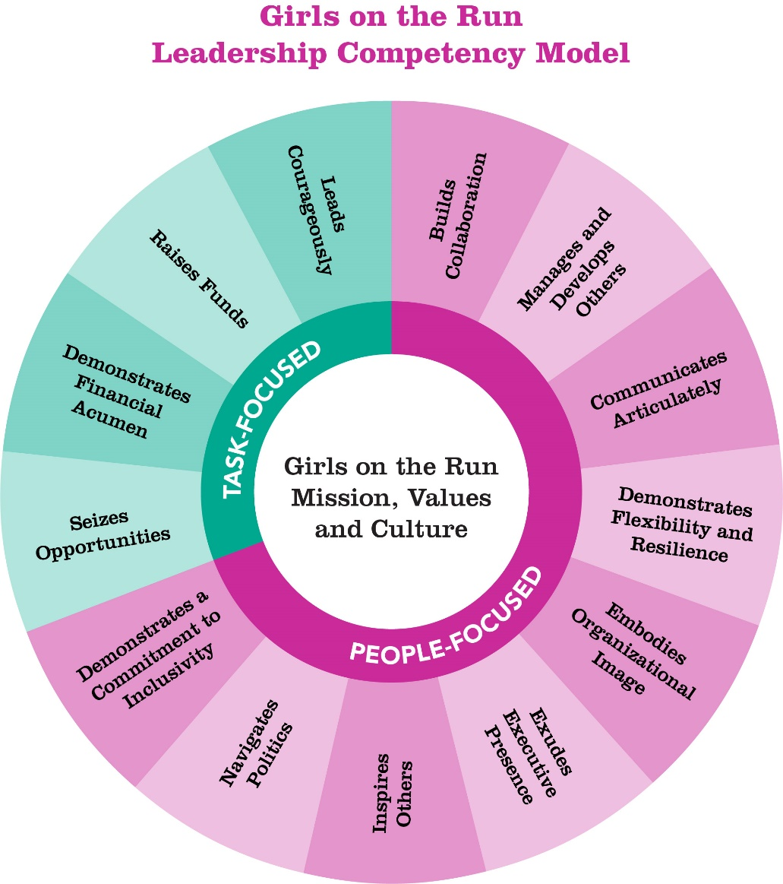

Builds Collaboration
Builds collaboration by communicating and reinforcing the organization’s mission and values. Invites and builds upon the ideas and contributions of others, promoting teamwork and celebrating accomplishments.

- Fosters collaboration across different functional areas and among stakeholders, staff, board, and volunteers
- Ensures others are well-informed of changes/new initiatives and progress towards goals.
- Establishes partnerships with community stakeholders and/or vendors.
- Seeks opportunities to build connections and engage people in the mission.
- Encourages and supports the contributions and success of others.
- Assists others in completing work assignments.
- Uses brainstorming or shared decision-making.
- Maintains open channels of communication.

Manages and Develops Others
Builds a strong team by helping others identify and work toward both personal growth and organizational goals. Provides clear direction and expectations in job responsibilities and project work. Remains accessible for assistance and support. Provides both positive and corrective feedback with individualized suggestions for improvement. Supports others and expresses positive expectations and encouragement. Is appropriately optimistic about future achievement.

- Demonstrates a commitment to success, growth, and development of others.
- Is accessible to employees for coaching.
- Shares expertise and experiences with others.
- Creates a culture of continuous learning and personal growth.
- Helps others learn job skills.
- Develops goals for self and staff and regularly provides specific, objective, and timely performance feedback.
- Delivers corrective feedback when needed.
- Provides suggestions for individual development.
- Turns mistakes into learning opportunities.
- Manages staff with professionalism, creating needed structure for staff to maximize their time and energy.
- Actively participates as a team member.
- Holds self and others accountable to follow through on commitments.
- Discerns high performance and culture fit in hiring process.

Communicates Articulately
Ability to actively listen and speak clearly and concisely and demonstrate skill in using expressiveness to convey important points in communications.

- Writes and speaks succinctly, striking a healthy balance between being brief, direct, and complete.
- Explains the “why” as appropriate.
- Actively listens to others before speaking. Uses questions for better understanding.
- Articulately conveys messages and accurate information in a timely manner with intentional cadence.
- Uses enthusiasm to make points.
- Speaks in business terminology when appropriate.
- Communicates complex information effectively in conversation, meetings, on the phone, etc.
- Targets use and level of technical language to the audience.
- Communicates effectively with individuals from a variety of backgrounds (e.g., cultural, educational, etc.).
- Appropriately open or protective with information, as needed.

Demonstrates Flexibility/Resilience
Adapts to and works effectively with a variety of situations, individuals, or groups. Adapts approaches as the requirements of a situation change. Manages pressure effectively and copes well with crisis, changes or setbacks.

- Demonstrate firm understanding of sustainability and key performance indicators.
- Is responsible for a significant piece of the organization’s business strategy.
- Takes broad strategic goals and develops the initiatives to achieve them.
- Ensures that strategy decisions align with the organization’s vision and objectives.
- Engages board in developing a strategic plan and direction for the organization.
- Communicates the organization’s strategy and vision within and outside the organization.
- Leverages data to inform strategies and measure success.
- Prioritizes and provides resources for key strategic initiatives.
- Sets measurable objectives for the organization.
- Manages organization with a business mindset to ensure effective operations.

Embodies Organizational Image
Supports and actively promotes the organization. Positively reflects the organization’s core values internally and externally. Lives the organization’s values on a day-to-day basis.

- Clearly driven by the mission of the organization.
- Supports and actively promotes the organization.
- Positively reflects and models the organization’s core values.
- Translates organization’s core values into behaviors.
- Considers the organization’s impact in the community.
- Identifies and addresses actions incongruent with the values of the organization.

Exudes Executive Presence
Leads others to follow through on difficult actions and initiatives. Presents self in a professional, convincing, and compelling manner.

- Leads by example.
- Willingly holds self and others accountable.
- Authentically connects to others.
- Sets the tone for the organization.
- Expresses complex issues with simplicity and conviction.
- Fosters an optimistic view of the future.
- Can communicate with people at all levels.
- Exudes authentic passion for the organization and its people.
- Maintains professionalism in all circumstances.

Inspires Others
Understands the organization’s mission and strategic vision. Communicates compelling visions, both short-term and long-term, to the organization.

- Articulates the organization’s mission and strategic vision.
- Develops both short-term and long-term organizational goals for maximum impact.
- Expresses the organization’s vision and values in a meaningful and compelling way.
- Guides others to see the long-term vision for organizational goals and outcomes.
- Fosters an atmosphere in which people can discuss organizational goals and vision.
- Inspires people to be engaged in the mission and the organization’s goals.
- Outwardly displays optimism about the long-term organizational impact.
- Communicates an appropriate sense of urgency to garner support and advance the mission.

Navigates Politics

Effectively navigates organizational politics and is able to work through different cultures and competing objectives within the organization.

- Understand the role of Board of Directors and supports their efforts to effectively govern.
- Leads others in aligning culture with strategy and values.
- Effectively balances competing objectives and perspectives in the organization.
- Recognizes and helps the organization benefit from differing cultures and business perspectives within the organization.
- Works effectively within the political realities of the organization.
- Manages board relationships to ensure organization effectiveness.
- Reinforces the core values of the organization.
- Ensures that organizational silos or differences do not hamper the organization’s effectiveness.

Demonstrates a Commitment to Inclusivity
Deeply committed on a personal level to being inclusive and continually works to become aware of and address biases. Aligns strategies and goals to ensure the organization is diverse, equitable and inclusive.

- Understands implicit bias and holds self and others accountable for overcoming personal biases.
- Embraces cultural differences.
- Works to break down systems of inequity.
- Integrates diversity, equity, and inclusion strategies into all aspects of the organization.
- Promotes organizational commitment to diversity, equity, and inclusion.
- Demonstrates empathy and compassion for others.
- Supports others in cultivating an inclusive mindset.

Seizes Opportunities
Is proactive and takes initiative and ownership for success. Anticipates potential obstacles. Does not wait to be told what to do. Exhibits a bias toward action. Ability to work independently for extended periods with minimal support and approval.

- Takes initiative with an appropriate sense of urgency.
- Anticipates and plans for potential obstacles.
- Able to quickly take advantage of opportunities or pivot when necessary to ensure relevancy.
- Takes action and avoids over-analysis.
- Takes ownership of difficult decisions.
- Accomplishes tasks with minimal support or direction.
- Expects high performance and pushes personal performance.
- Takes personal responsibility for self-development.
- Seeks expert guidance or resources when needed.
- Overcomes performance barriers.

Demonstrates Financial Acumen
Understands the organization's financial environment, uses resources wisely and makes fiscally responsible decisions.

- Demonstrates clear understanding of the organization’s financial position, risks and liabilities
- Understands the drivers of financial success.
- Monitors the organization’s progress toward its financial goals.
- Analyzes and communicates financial trend data.
- Keeps abreast of broader economic data and trends that impact the organization.
- Protects the financial health of the organization.
- Manages with the key financial performance indicators of the organization as a priority.

Raises Funds (Fund Development)
Knowledgeable on all aspects of successful and strategic fundraising. Develops fundraising plan and sets specific goals. Leverages diverse revenue streams to contribute to financial stability. Savvy at calculating return on investment across varied fundraising initiatives.

- Develops effective strategies by being attuned to emerging trends in nonprofit fundraising.
- Identifies the organizations fundraising requirements. Develops fundraising goals and tactics to achieve strategic plan and budget.
- Establishes and effectively communicates a case for support.
- Recognizes the importance of relationship building in successful fund development
- Strategic and successful in cultivating and stewarding relationships.
- Effectively implements fundraising strategies and tactics.
- Oversees fundraising functions of the organization.
- Evaluate the effectiveness of fundraising strategies and associated initiatives.

Leads Courageously
Demonstrates authentic leadership of initiatives and situations with confidence and courage. Willing to practice vulnerability and humility. Is proactive and decisive in tough circumstances. Takes responsibility for making difficult decisions. Shares feelings, opinions and needs with clarity and conviction. Does not avoid conflict or differences.

- Provides proactive leadership of key initiatives.
- Demonstrates confidence around critical initiatives.
- Displays diplomacy and humility.
- Willingly takes control of situations requiring decisive action. Takes an active stand in difficult situations. Makes tough decisions.
- Conveys confidence in the capability of the organization.
- Demonstrates self-awareness and emotional intelligence.
- Handles conflicts and differences in opinion effectively.
- Follows through on decisions.
- Practices being vulnerable with other and cultivates an environment that promotes vulnerability from others.
- Willing to take risks and practice courage.
- Builds and maintains trusts with others.
- Engages and maintains attention in high-stake meetings and discussions.

