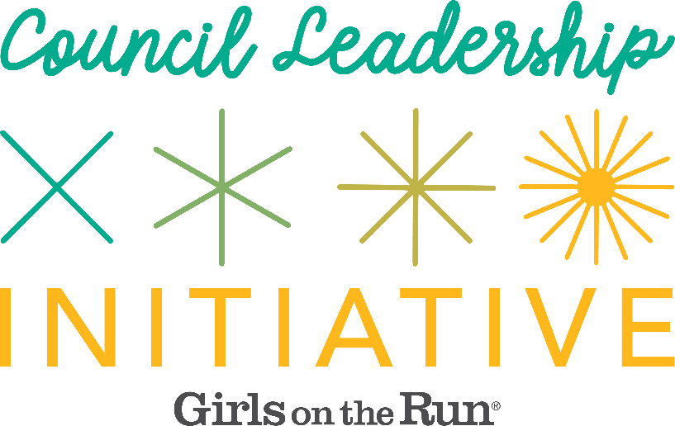
READ FIRST: Introduction to the Council Leadership Initiative (CLI) Resources

The Council Leadership Initiative (CLI) is designed to give engaged, IDEA-motivated boards and hiring teams the tools to deepen equity and inclusion in their hiring practices. Using a combination of educational resources, templates, and consultative support, the CLI is intended to empower participating teams to build a recruitment that forwards GOTR’s IDEA strategic imperatives and is reflective of GOTR values.
The CLI includes access to BambooHR, an applicant tracking system, as well as general hiring resources and templates for Executive Director searches. In some cases, HQ can provide additional layers of tier-level support:
Tier 1: Access to HQ’s applicant tracking system, BambooHR.

Tier 2: Access to BambooHR along with recruiting guidance and candidate selection support from GOTR HQ. (Best suited for Executive Director and senior-level program or development staff positions.)

Tier 3: Access to BambooHR and full recruitment support, including interview preparation and support as well as candidate assessment from a council development team member or a member of the HR team. (Best suited for Executive Director positions and other key strategic positions.)

Tier level support will be determined based on a variety of factors, including position level, council needs, and recruiting capacity, among other considerations.
Recruiting top talent is an ambitious and involved process that requires strategic intention and execution. The resources created through the CLI provide you with creative and equitable processes that can lead to shared vision, strategic alignment and the future success of your council.

