Table of Contents
- Introduction
- What is a strategic plan?
- IDEA Strategic Planning toolkit
- Council Build Back toolkit
- Five Step Process Overview
- Step One: Define Mission, Vision, and Values
- Step Two: Pre-Planning
- Step Three: Creation
- Step Four: Implementation
- Step Five: Monitor & Evaluate
- Resources and Case Studies

Introduction
The Strategic Planning Five-Step Process Guide is a comprehensive planning toolkit designed to support councils with creating achievable goals and measurable objectives that can be developed, executed, and managed at a council level in partnership between staff and board. In this five-step guide, you’ll learn the basics of the strategic planning process and how a strategic plan guides you to achieving your council’s goals.
Councils will continue to incorporate Girls on the Run (GOTR) HQ’s organizational goals and standardized metrics that pertain to the entire council network, including the Mission Advancement Markers, IDEA Strategic Imperatives, and GOTR HQ’s Strategic Map into your strategic plan.

What is a strategic plan?
A strategic plan serves as a roadmap and as a tool for assessing progress and celebrating milestones.
A strategic plan generally covers three to five years and communicates goals, objectives, and the strategies (activities/tasks) it takes to achieve them. The strategic plan is monitored and evaluated to ensure that goals are being met and celebrated. The strategic planning cycle is ongoing, and the plan can be adjusted along the way, especially during the monitoring and evaluation process.

How do we incorporate the IDEA Strategic Planning toolkit into future planning?
The IDEA Strategic Planning toolkit will be phased out at the end of 2023; however, since the goal is for IDEA to be embedded in all aspects of our work, IDEA-centered activities from the toolkit will remain relevant for council strategic planning. Councils can continue to use the following activities from the IDEA Strategic Planning toolkit: Taking Action on IDEA, Strategic Imperatives, Readiness Matrix, and External Focus Group Questions.

How do we incorporate the Council Build Back Stronger toolkit into future planning?
The Council Build Back Stronger toolkit will be phased out at the end of 2023. Councils that have not built back to 2019 girls served and FY19 revenue should continue to work towards these goals as part of future planning. Girls served growth and revenue growth indicators have returned as Mission Advancement Markers to support councils in assessing their progress.

How do we incorporate GOTR HQ’s Strategic Map into future planning?
The organizational strategic map sets the direction for our entire organization and all council strategic plans should funnel up to the organizational marathon goals.

Five Step Process Overview

There are five basic steps to a strategic planning process. This process guide will review each step. For additional information about each step, be sure to check out the Strategic Planning Three-Part Mini-Webinar Series on the GOTR Learning Academy.
- Define Mission, Vision, and Values
- Pre-Planning
- Creation
- Implementation
- Monitor and Evaluation

Before each step is reviewed, let’s get grounded in some visuals that may help set the stage for the five-step process.
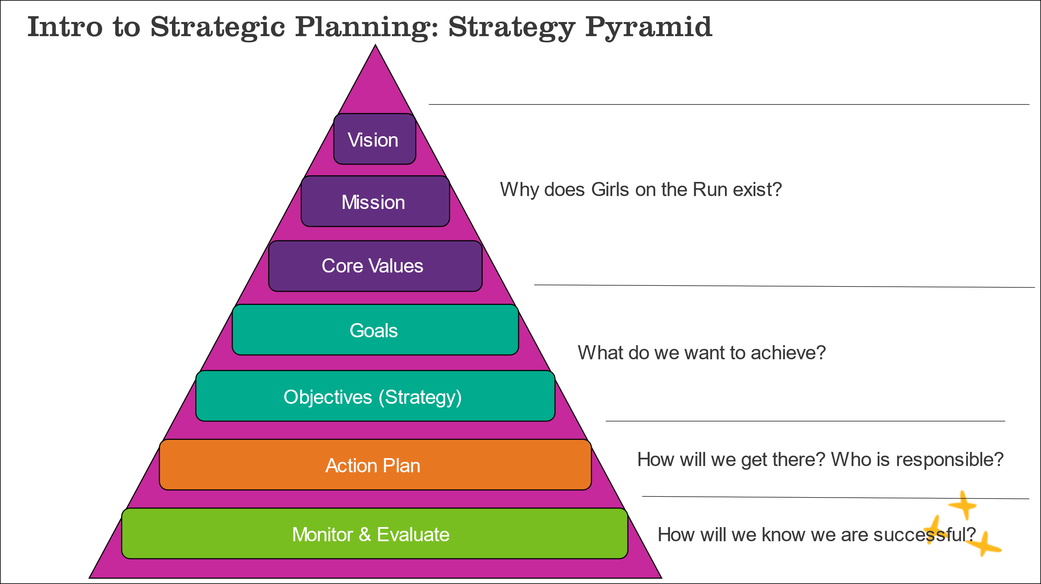
The below Strategy Pyramid details the elements of a strategic plan and the “why”, “what”, or “how” that each element is connected to.
The five-step process map below details the order of the five steps and the major activities associated with each. This process map can dually serve as a check list for order of operations. The amount of time each step will take will vary but for some suggestions, review the start to finish checklist on the Council Portal and Board Resource Page.

The planning cycle timeline below outlines an example of when each of the five steps could occur during an annual cycle, especially if you are aligned to fiscal board governance operations.

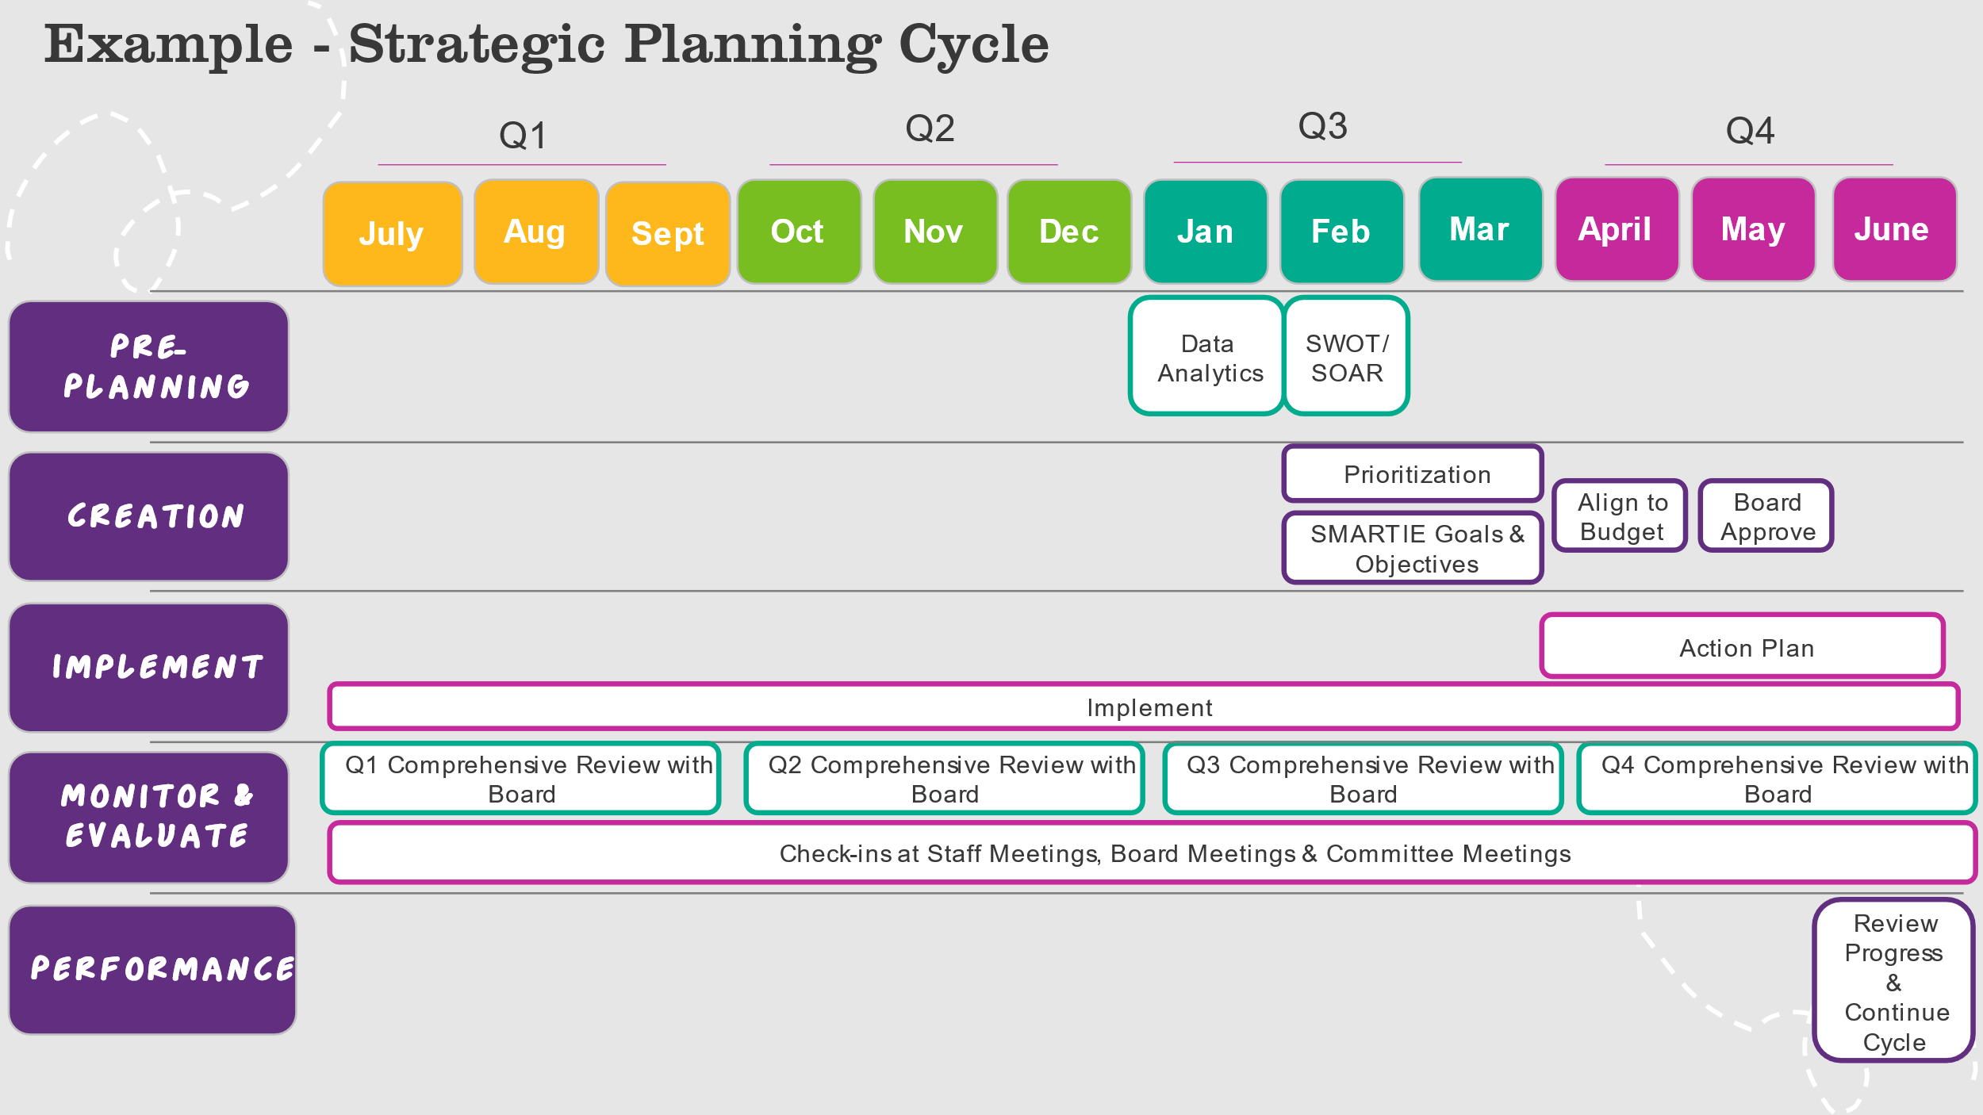

Step One: Define Mission, Vision, and Values
It is still critical for councils to align their goals and objectives to Girls on the Run’s vision, mission, and core values. However, since councils are part of a federated model, the vision, mission, and core values are set by GOTR HQ. This eliminates a critical part of the strategic planning process and allows councils to focus on the other four steps.

Step Two: Pre-Planning
Who will lead and manage the strategic planning process?
- The development, execution, and management of the strategic plan is a partnership between the staff and the board.
- The key players will look different at each council but, at minimum, should always include a collaboration between the council director and board leadership. Other scenarios could incorporate the council director plus the governance committee, executive committee, or other board-led committee (i.e.: strategic planning committee).
- Depending on the life cycle of the council or new initiatives on the horizon, a council may occasionally opt to utilize an external facilitator or consultant to lead the process. However this isn't often needed unless significant changes or goals are happening at the council (ie: new territory, different service model, etc.). This Strategic Planning: Five-Step Process Guide is designed to create a sustainable process that is internally lead and managed.
  - Supporting Resource(s) on Council Portal and Board Resource Page: Executive Director Job Description, Board Member Position Description and Ten Basic Responsibilities of a Board
Are staff involved in the strategic planning process?
- Involving staff in the planning process is important to achieving buy-in, especially when it comes time to implement. There are a few great ways to include staff in the strategic planning process.
  - Participate in SWOT Analysis: Staff input is necessary and valuable. If your council is hosting a planning session and staff will be present, staff can participate in the SWOT analysis portion of the session. (note: staff should be removed from any other sessions that discusses sensitive information)
  - Collect Feedback Prior: If staff will not be present for the SWOT activity, administer a survey or collect feedback that can be represented in the SWOT analysis activity. Be sure to ask the same questions included in a SWOT.

When do we create the plan? How many years should it cover?
- There are certain times of the year that make more sense to create a strategic plan based on the timing of board governance operations, however, a plan can be created at any time during the year. Since a strategic plan is part of healthy board governance operations, the steps of planning can occur over time during regular scheduled board meetings as part of board business or a council may opt to host planning sessions or a retreat. The Governance Timeline outlines how strategic planning fits seamlessly into annual board governance and the Strategic Planning Cycle showcases the five step process throughout the year.
  - Supporting Resource(s) on Council Portal and Board Resource Page: Governance Timeline and Strategic Planning Cycle
- The number of years that the plan includes depends on the council and many factors will determine whether you create a one-year plan, a three-year plan, or even a five-year plan. However, there are some benefits to consider for a longer-term plan, traditionally three years. All of the following reasons allow for a council to confidently plan beyond one year:
  - Our mission, vision, and core values are static. We know that next year and in years to come, these will remain.
  - Overall, our program offerings will not change. This allows for the council to plan into the future, beyond a year, knowing that new program offerings (will not impact the goals of the plan.
  - GOTR HQ has a 3-year strategic map that sets direction for the entire organization. All council goals funnel up to the marathon goals.
  - GOTR HQ develops, evaluates, and updates our organizational MAMs.
How do we know what the future direction of the council should be?
- Before a strategic plan can be developed, the council will need to conduct an environmental scan. An environmental scan gathers information, both quantitative and qualitative, as well as internal and external, to help determine the future direction of the council.
  - Supporting Resource(s) on Council Portal and Board Resource Page: Environmental Scan: Data Collection List
How do we narrow down what our goals and objectives should be?
- A critical part of the pre-planning process is conducting a SWOT (strengths, weaknesses, opportunities, and threats) analysis. A SWOT analysis assesses internal and external factors, as well as current and future potential.
- A SWOT analysis is most successful after reviewing the key findings from the environmental scan. The environmental scan supports a realistic, fact-based, data-driven look at the strengths and weaknesses of an organization.
- As part of the SWOT activity, you will narrow down and prioritize your goals. Utilize the Pre-Planning Data Analytics Discussion Questions located on the Council Portal to guide conversation.
- This is a very important part of the activity as it provides consensus on what the council WILL DO and WILL NOT DO. You can’t do it all, and to make the plan achievable, you will need to prioritize.
  - Supporting Resource(s) on Council Portal and Board Resource Page: Pre-Planning Data Analytic Discussion Questions
  - External Resource: YouTube Video How to Perform a SWOT Analysis and How to Use a SWOT Analysis;

Step Three: Creation
How do we create our goals and objectives?
- After the SWOT analysis activity has been completed and themes are prioritized, it is time to create your goals and objectives.
- The number of goals and objectives per council will vary based on council resources, capacity, and priorities.
- All council’s strategic plans should address participant served growth, revenue growth, staff/board diversity, participant diversity, and coach diversity.
- Based on the environmental scan councils will have other goals and objectives specific to them.
How to write a goal:
- A goal is an outcome you want to achieve, broad statements, intangible, or non-measurable.
- Goal Example: Eliminate barriers to participation in Girls on the Run.

How to write a SMARTIE objective:

- An objective is a specific and measurable action that can be reached in a certain amount of time, related to a goal.
- A SMARTIE objective is Specific, Measurable, Achievable, Relevant and Timely + Inclusive and Equitable
- SMARTIE Objective Example: Serve 500 participants spring 2024 and increase our BIPOC participant representation by 5% to mirror the community that we serve.
How do we ensure we have the funds and/or resources to reach our desired outcomes?
- Along the way, it will be critical for the Finance Committee or Finance Chair to be evaluating the impact on the budget and making adjustments to support the efforts of the plan or raise concern for insufficient funds. The Fund Development Committee and Executive Director and/or Development position can play a critical role in supporting any additional or increased revenue to support the plan.
Does the board need to vote on the strategic plan?
- Yes! There will be some back and forth with revisions but once the strategic plan incorporates the board’s feedback and has the executive director’s seal of approval, it goes to the board for a vote, typically before the budget is approved.

Step Four: Implementation
There is so much to do! How will we get it all done?
- An action plan is a planning tool that lists what activities/tactics must be taken to achieve a specific goal, who is responsible and by when. It breaks down the goal into actionable steps that can be easily followed and monitored.

- After your strategic plan is approved, it is time to create the action plan. Leads for each objective must be identified. The leads manage the overall objective and work with any staff and/or board responsible in achieving the objective by outlining their specific tasks.
  - Supporting Resource(s) on Council Portal and Board Resource Page: Action Plan Template

There are six steps to creating an action plan:
- Write goals and SMARTIE objectives: During the strategic planning process you identified your goals and objectives. These goals and objectives will become part of the action plan so you can identify your tasks.
- Identify Tasks: Now that your goals and objectives are clearly defined and written down, you’ll want to identify the steps you have to take to reach them.
- Allocate Resources: Once you’ve outlined all of your tasks, you can allocate resources like team members, project budget, or necessary equipment.
- Prioritize & Sequence Tasks: When your team is clear on their priorities, they know what work to do first and what work they can reschedule if necessary.
- Set Deadlines & Milestones: When your team knows what they're working towards, they have the context to effectively prioritize work and the motivation to get great work done. Team members tend to be more motivated when they directly understand how their work is contributing to larger goals.
- Monitor: It’s crucial that you monitor progress and revise the plan when necessary. Setting deadlines and milestones will help you assess your progress and revise if necessary.

Step Five: Monitor & Evaluate
How do we keep the strategic plan top of mind and ensure we are making progress?
- It is all too common for a strategic plan to be developed and then never revisited again. The best way to monitor your strategic plan is to create and utilize a monitoring and evaluation framework with check points along the way to monitor impact.
- Start every staff meeting, board meeting, and committee meeting with updates on progress to the goal.
- At the end of the fiscal or calendar year, you will evaluate the performance of the goals and objectives. Utilize an end of year staff meeting and board meeting to comprehensively review the targets that were missed, met, or exceeded and gather lessons learned to inform the upcoming year.
- In addition to monitoring progress, it is important to celebrate milestones!
- The strategic plan is a roadmap and can be adjusted along the way to compensate for changes.
  - Supporting Resource(s) on Council Portal and Board Resource Page: Monitoring & Evaluation Framework Template

There are six steps to monitoring and evaluating your impact:
- Define your indicators: Indicators are measurable and specific criteria that show the progress and outcomes of your plan. They can be quantitative, such revenue or girls served or qualitative, such as feedback or testimonials.
- Collect your data: Data is the evidence that supports your indicators and shows the actual performance of your plan. You can use various sources and methods to gather your data, such as surveys, interviews, focus groups, observations, reports, or analytics. You should collect your data regularly and ensure that your data is accurate, complete, and consistent.
- Analyze your data: Data analysis is the process of interpreting and understanding your data and finding patterns, trends, and insights. You can use different tools and techniques to analyze your data, such as charts and graphs.
- Report your findings: Reporting your findings is the way of communicating and presenting your data analysis and results to your stakeholders, such as your team or board. You can use different formats to report your findings, such as written reports, presentations, or dashboards. You should also highlight the key messages, conclusions, and recommendations of your report.
- Implement your recommendations: Recommendations are the actions that you suggest based on your data analysis and findings to improve the impact of your strategic plan.
- Monitor and review your impact: Monitoring and reviewing your impact is the way of tracking and evaluating the results and outcomes of your recommendations and plan. You should use the same indicators and data sources that you used in the previous steps and compare them with your baseline and targets.

Resources and Case Studies
Note: For board members without a Council Poral login, please visit the Board Resource Page for board-related resources. (no login required)

New Resources
  - The Strategic Planning Five-Step Guide
  - The Strategic Planning Three-Part Mini Webinar Series
  - Environmental Scan – Data Collection
  - Data Analytics – Discussion Questions
  - Strategic Planning Timeline Example
  - One Page Strategic Map Template
  - Action Plan Template
  - Monitoring & Evaluation Framework Template
  - The Strategic Planning Five-Step Guide
Council Case Studies + Presentations
  - Territory Expansion
  - Strategic Growth
  - Maximizing Staff Structure
  - Diversifying Fund Development
  - Staff & Board Leadership Representation *coming soon*

Existing & Supportive Resources
  - Board Fundamentals Webinar Series (GLA)
  - Governance Timeline
  - Organizational Goals – GOTR HQ Strategic Map
  - Mission Advancement Markers
  - Inclusion, Diversity, Equity and Access

